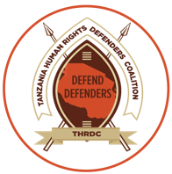 |  | Deogratius Chambi  IT and Digital Security Officer | Tanzania Human Rights Defenders Coalition(THRDC)  Mikocheni B - Near Hekima Garden | P.o Box 105926, Dar es salaam - Tanzania  Mobile: +255 712 196 222 | Signal: +255 712 196 222  Website: www.thrdc.or.tz | Office Mob: +255 769 642 208     

Defending Human Rights is not a crime.

